Team Action Plan Assignment (worth X pts)
This is part of the team project's planning and communicating efforts. It builds on the Workflow/Charter document. It should be updated weekly.
GOALS AND PURPOSE
The Project Action Plan will be a modification or extension of the Team Charter. As such the team can choose to have this action plan as a separate document OR as an update to the Workflow. Keep reading to find out more.
The Team Action Plan is a more comprehensive articulation of how all of the moving parts of this project will work. The stretch goals are that it helps to organize—for all team members--all discrete tasks and work until the final version of the project is due.
This plan will help everyone to understand how tasks are assigned, when team internal due dates are set, and when and how the team will finalize the final deliverables for submission.
OUTCOMES
Communication; communicating and working in teams; task management; professional workflow habits
TASKS
- The team should review its revised Charter with the specific project in mind.
- The team needs to look at [date] as the next major due date, which is a Progress Report.
- Decide how much work should be done by [date] for the project.
- Assign all relevant subtasks to each person for the [date] due date.
- Determine how tasks, subtasks, and even sub-subtasks will be assigned AND how due dates for each of those items are determined and communicated to everyone (including the instructor). This could be through a range of tools and methods which could include Google Calendar/Tasks, Trello, Google Sheets, a pinned email post, something inside Slack or Discord, or something else entirely. Refer to your Team Charter.

continued

- For each upcoming work week, each team member should fill out a simple table in advance and as work unfolds that tracks these items:
  - Name and summary of that week's tasks.
  - Column 1: Date due (the internal team deadline)
  - Column 2: Name of the task, subtask, or sub-subtask
  - Column 3: Done, not done, or in progress
  - Column 4: Hours (or minutes) predicted to complete task
  - Column 5: Actual time used to complete task
Here’s an example.
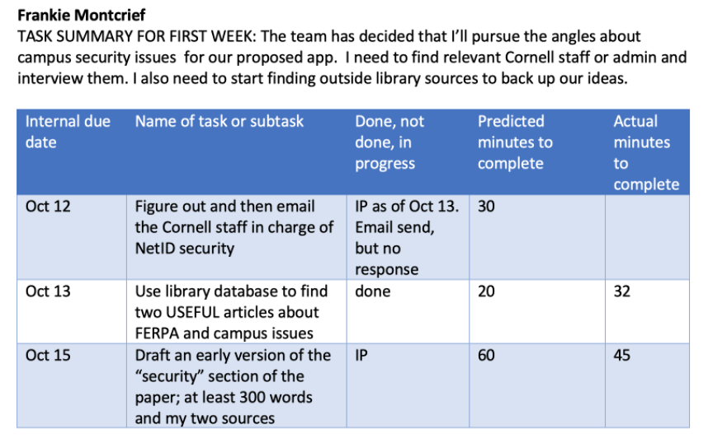
Items that could/should be included in the table include team meetings, editing, asynchronous team communication, etc. The hope is that no team member should exceed nine hours in any given week, but that all members contribute at least five hours each week.

SUBMITTING THE ASSIGNMENT
One person from the team can upload the PDF for the entire team. The PDF will allow the instructor to use Canvas markup.

